Western Bat Programmatic Biological Opinion (PBO) and Programmatic Conference Opinion (PCO) for the following bat species: Indiana bat (Myotis sodalis, MYSO), gray bat (M. grisescens, MYGR), northern long-eared bat (M. septentrionalis, MYSE), tricolored bat (Perimyotis subflavus, PESU), and little brown bat (M. lucifugus, MYLU)
link to Programmatic Biological Opinion https://connect.ncdot.gov/resources/Environmental/EAU/BSG/Documents/Bats/Bat%20Programmatic%20(Div%209-14)/WNC%20Bats%20PBO%20Div%209-14%20(2025).pdf

For NRTR Documentation for projects in Divisions 9-14, we typically do not produce a BC at this time not knowing what construction activities will occur. It is our protocol to show a BC of Unresolved until we get closer to project permitting and can determine impacts and develop a biological conclusion for listed animal species. The blurb below is appropriate for this stage of project planning.

Biological Conclusion: Unresolved
As of [Date], the following federally protected bat species are listed in IPaC (https://ecos.fws.gov/ipac/) as occurring in the action area: [list of species in IPaC]. Construction activities for this project are unknown at this stage in project planning, NCDOT will resolve Section 7 prior to let as appropriate.

To be included in NEPA/SEPA Documentation for projects in Divisions 9-14.
The U.S. Fish and Wildlife Service (USFWS), in partnership with the Federal Highway Administration (FHWA), U.S. Army Corps of Engineers (USACE), and NCDOT, has issued a combined Programmatic Biological Opinion (PBO) and Programmatic Conference Opinion (PCO) for the following bat species: Indiana bat (Myotis sodalis, MYSO), gray bat (M. grisescens, MYGR), northern long-eared bat (M. septentrionalis, MYSE), tricolored bat (Perimyotis subflavus, PESU), and little brown bat (M. lucifugus, MYLU). Per current design and construction plans, the project is eligible for PBO use and NCDOT can adhere to the appropriate CMs. The proposed biological conclusion for bats is [BSG will determine this using pg. 33 of PBO Table 5 to determine effect for project - pasted below]. The PBO will ensure compliance with Section 7 of the Endangered Species Act for five years (effective through April 1, 2030) for all NCDOT projects with a federal nexus in Divisions 9-14, which includes [XXXX County] , where [PROJECT #] is located.

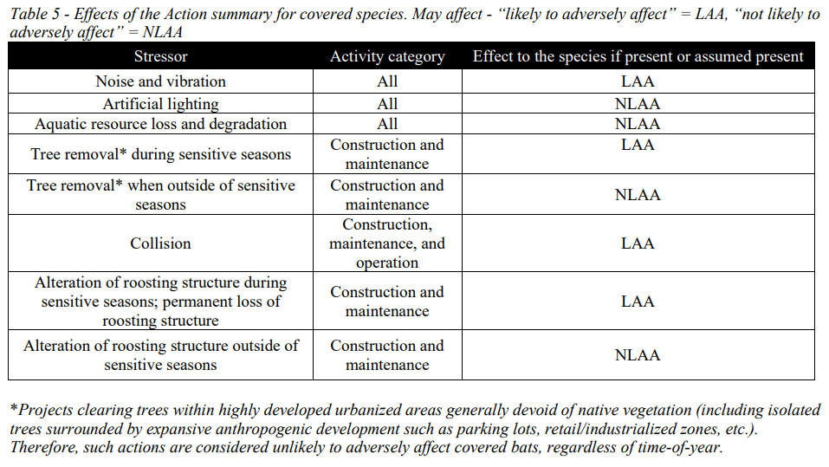

PROCESS FOR USING western bat PBO:
ECAP or Division Environmental Staff will provide the following information to BSG

As of April 2025, BSG is has created a map of the protective buffer areas and is streamlining this process into an interactive online map and online submission form. But in the meantime, if you have a project you would like to use the western bat PBO, please fill in the information below and email it back to clknepp@ncdot.gov so BSG can track all projects used in PBO and then submit them to USFWS.

Project-Level Pre Notification
NCDOT Biological Surveys Group will monitor project implementation to ensure all identified conservation measures are implemented, ensure the appropriateness of the opinion’s application, and track take. For each project conducted under this programmatic opinion, the NCDOT project manager will provide the NCDOT BSG with the following information prior to the start of work:

• A brief description of the proposed action (e.g., type of action, let date, location - lat/long, timeline, involved federal agencies).
• List of covered bat species associated with the individual project (IPaC -generated species list and date generated).
• A quantification of impacts (e.g., acres of tree removal, timing of tree removal, type and timing of structure work – if unknown, put that and we will submit worst case).
• Identification of all applicable conservation measures to be implemented (leave blank, BSG will determine this for now based on buffer map).
• Findings of any bat survey work conducted in relation to the covered project, including documents such as completed structure survey forms, photographs, etc. (BSG should have this if everything was turned in to us to enter in the database)
• A brief summary outlining how project impacts on covered bats align with the effect determinations and associated biological rationale presented in this document (Example: Tree clearing will occur during sensitive seasons and will = LAA for IBat and NLEB; Bridge replacement will occur outside of active season and replacement will provide suitable roosting features = NLAA for gray bat, IBat, and NLEB – leave blank BSG can determine this based on the impact information you provide above, pictures are best for determining impacts regarding structures so if you have WIGINS reports or high water supplement reports for damage resulting from a disaster that would help us a lot).

